|  |  |  |  |
| --- | --- | --- | --- |
|  | Bansilal Ramnath Agarwal Charitable Trust's  Vishwakarma Institute of Information Technology  **Department of**  **Artificial Intelligence and Data Science** | | |
| Name: Siddhesh Dilip Khairnar | | | |
| Class: SY | Division: B | | Roll No: 272028 |
| Semester: III | | Academic Year: 2022-2023 | |
| Subject Name & Code: Data Structure, ADUA21202 | | | |
| Title of Assignment: Implement polynomial using Doubly Linked List and perform Addition of Polynomials | | | |

**Assignment No.- 4**

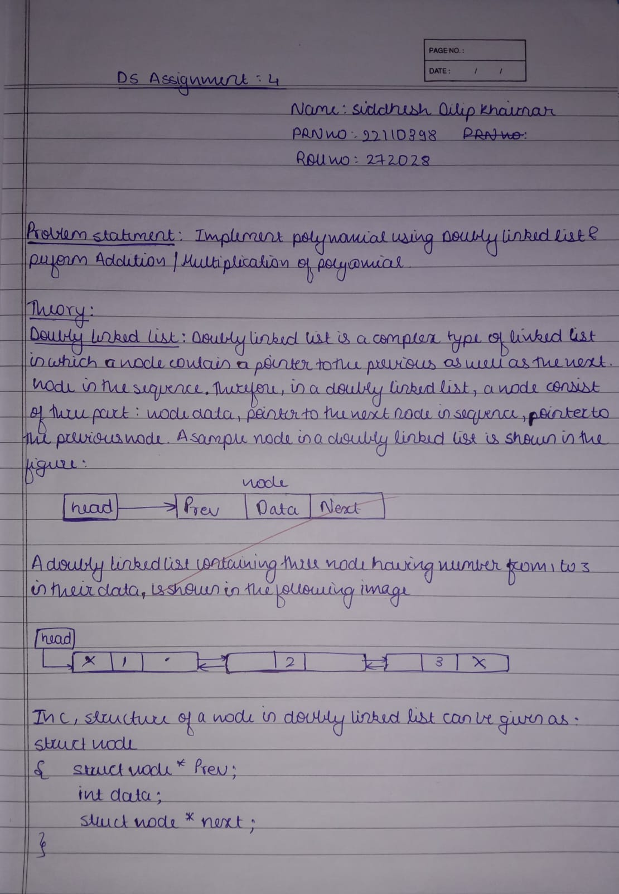

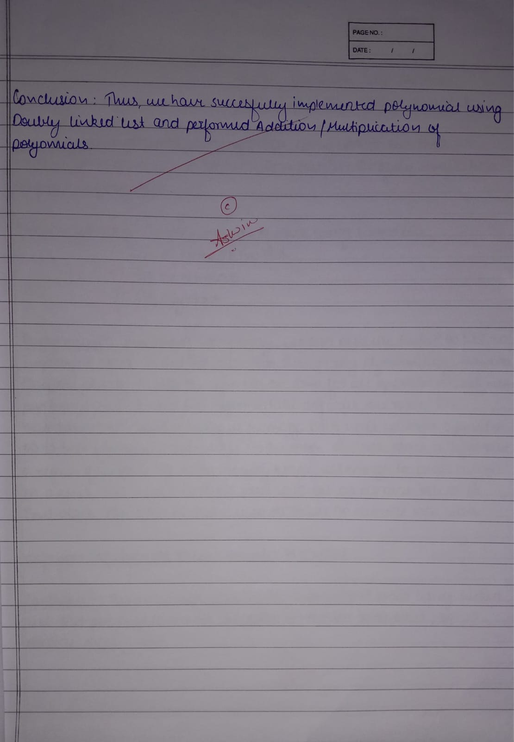

**Program:**

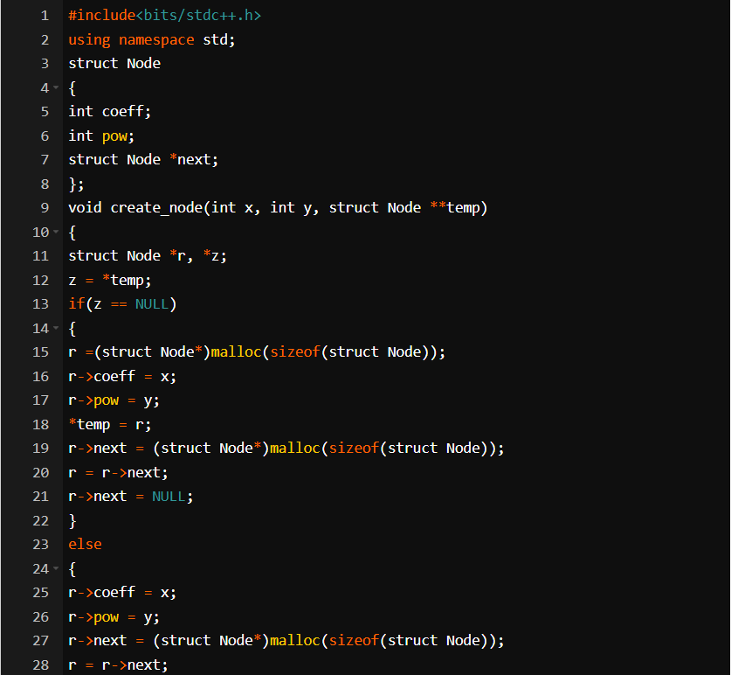

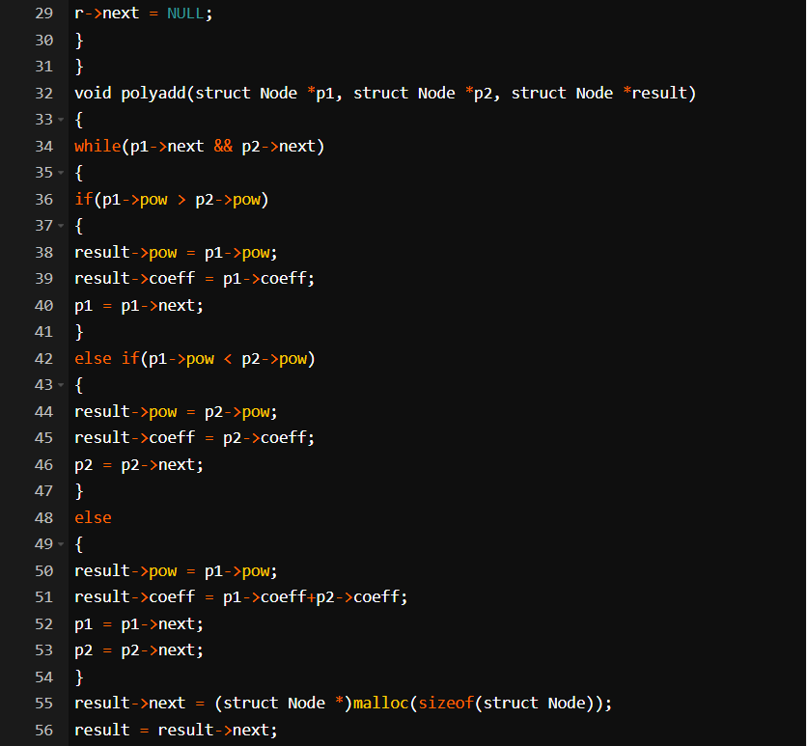

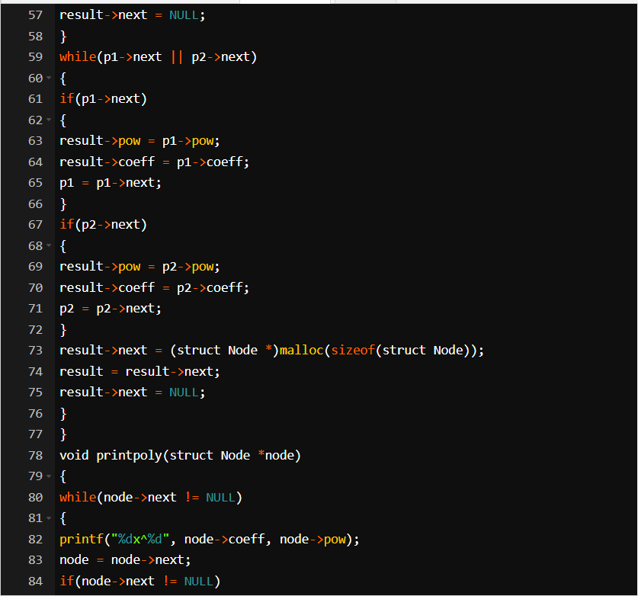

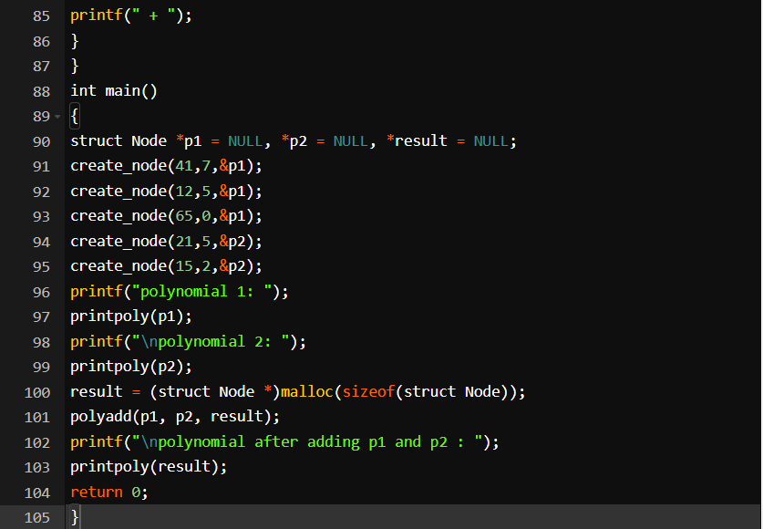

**Output:**

